**FPT ACADEMY INTERNATIONAL**



## FPT – APTECH COMPUTER EDUCATION

AKSME-MOBILE

|  |  |  |  |
| --- | --- | --- | --- |
| **Center Name** | | FPT – Aptech – HCM2  Address: 590 Cach Mang Thang Tam, District 3, Ho Chi Minh City | |
| **Instructor** |  | Ms. Le Mong Thuy |  |
| **Class** |  | T1.2302.E1 |  |
| **Group** |  | 5 |  |
| **Group members** | | **Name** | **Student ID** |
|  |  | Nguyen Quoc Duong | Student1457507 |
|  |  | Huynh Yen Phung | Student1457502 |
|  |  | Nghiem Kha An | Student1457501 |
| **Duration** | Start date | 23rd May 2023 |  |
| End date | 22nd June 2023 |  |

**This is to certify that**

**Mr./Ms.:**

Nguyen Quoc Duong

Huynh Yen Phung

Nghiem Kha An

**has successfully designed & developed**

eProject: AKSME-MOBILE WEBSITE

**Submitted by:**

Nguyen Quoc Duong

**Date of issue:** May 23rd 2023

**Authorized Signature:**

|  |
| --- |
| ***TABLE OF CONTENTS*** |
| **FPT – APTECH COMPUTER EDUCATION** |
| PROBLEM DEFINITION 3 |
| CUSTOMER'S REQUIREMENTS SPECIFICATIONS (CRS) 4 |
| Business/Project Objective: 4 |
| Hardware/ Software Requirements: 5 |
| SCOPE OF THE WORK (IN BRIEF) 6 |
| Architecture and design of the system 7 |
| Diagram of the website 8 |
| SITE MAP 10 |
| MOCK OF THE WEBSITE 11 |
|  |
| **WEB DESCRIPTION** |
| 1. Home page 19 |
| 2. Product 20 |
| (Example of detailed information page) 21 |
| 3. Compare 21 |
| 4. About us 22 |
| 5. Contact Us 23 |
| **JAVASCRIPT DESCRIPTION** |
| 1. Zoom picture function 24 |
| 2. Compare page function 25 |
|  |

# PROBLEM DEFINITION

The Web site is to be created based on the following requirements:

1. The Home Page should be created with proper sections, graphics and logo.
2. A Menu should be created which would categorize all the information about the features provided in the Site.
3. The information should be categorized according to the Brand names of Mobiles like if a User wants to see only Nokia Phones then he click on Some Nokia Link/button etc and he will see only That Brand phones and so on.
4. A Brief summary of features of Individual phones should be displayed on the Web Page along with the Cell phone but detailed Features should be stored in Individual Word documents which can be downloaded or viewed by the User who wishes to see the same.
5. A Comparison Web Page should also be there where there is Phone comparisons done with various models of same brand or various models of various brands.
   * The Comparison information should be provided in Tabular format comparing the features of different phones.
   * This information would be for 5 Phones of similar brands and 2 phones of different brands for 1 month and then it will change so for the time being the Page should handle the above requirement.
6. The Colour Schemes should be soothing, more of Pastel Colours can be chosen for the same.
7. When a particular brand phones are being displayed the background image of the Web page should show the Logo of that brand for e.g. if Nokia Phones are being displayed then that page should have the Logo of NOKIA as the background image and the same in case of other Brands.
8. There should be a “Contact Us” page which will have the Address of the Company which is as follows and the mail address which when clicked will invoke the local mail client from where they can send an email.

Address of the Company: A-65, ACME Co., Street no 12, New York

Phone Numbers: +001-28272300, 2466, 2469

Email Address: [webmaster@cellinfo.com](mailto:webmaster@cellinfo.com)

1. The information on the mobile phones and all can be picked up from the Sites of

Nokia, Samsung etc.

10. To avoid creation of html pages you can make use of layers, flash buttons and

other components of

Dreamweaver for creation of pages.

11.The appearance and organization of the site will carry more chances of your

selection for getting the contract so both the factors are important to be considered.

# 

# CUSTOMER'S REQUIREMENTS SPECIFICATIONS (CRS)

**Client: *AKSME_MOBILE***

### Business/Project Objective:

ASKME Ltd. Is a Multi National Company providing Information services to General People

they have been providing information to people through Telephone calls which could include

anything from Pin to Piano. Their major source of income comes from informing the customers

about those products first for which ASKME is getting paid for.

We are supposed to create a website for yours with the below mentioned requirement specifications.

The website is to be developed for the Windows Platform using HTML5, JavaScript and Geolocation. The site should work well in all leading browsers including Chrome, IE, Firefox etc.

**Input to the system:**

* + - * Searching products depend on price, brand and information about

The AKSME_MOBILE.

* + - * Feedback about the quality of products.
      * Register members on website.

**Output from the system:**

* Perform search based on: brand, product type, voltage, capacity...
* Display results for each type of product according to the search content.
* Display product information by price, specifications, brand, image, color, model...
* Displays FAQ and allows users to email directly to the company
* Success/error message from website to web visitors

**Process**:.

* + - * Validate data input from users.

**Expected delivery date:** 22-Jun-2023.

**List of deliverables:**

* + - * Document Word.
      * User Guild.
      * Source code.

### Hardware/ Software Requirements:

* **For webmaster**

**Hardware**

* A minimum computer system that will help you access all the tools in the courses is a Pentium 166 or better
* 64 Megabytes of RAM or better

**Software *[Either or Combination as per Course/Sem]***

* Notepad/HTML editor/CoffeeCup
* Angular / Angular JS / React / BootStrap
* Dreamweaver / Figma
* MS IE / Chrome / FireFox / Netscape /MS Edge

### For web users

**Hardware**

* + Intel Pentium 4 processor or higher
  + 512 Megabytes of RAM or higher

### Software

* + Windows XP OS or higher
  + Web browsers such as IE, Chrome or Firefox are supporting HTML5, CSS3 and Javascript.

# SCOPE OF THE WORK (IN BRIEF)

After a long and detailed discussion, our group has decided to create a website contain the following webpages:

1. ***Homepage***: Display information about newest-selling products, an introduction about Richfield chairs.
2. ***Products***: Display a catalogue of chairs according to their brands, function and the search section for customers to look for their wanted chairs, feedback of visitors to webmaster.
3. ***Compare***: Allow customers to compare types of chairs in terms of their brands or price.
4. ***About Us***: Display the information of the company, clients’ review and about us.
5. ***Contact***: Display the address of the company, allow customers to request any information they want to AKSME MOBILE.

# Architecture and design of the system

Webpage request



Requested Page

**RENDERING**

**ENGINE**

**CSS CODE**

**HTML CODE**

**WEB SERVER**

**WEB BROWSER**

**CLIENT**

**SERVER**

# Diagram of the website



Request info

## 

**BEGIN**

**HOME**

**PRODUCTS**

**COMPARE**

**ABOUT US**

**CONTACT**

**REGISTER**

**LOG IN**

**END**





**TASK SHEET REVIEW 1**

|  |  |  |  |  |  |  |  |
| --- | --- | --- | --- | --- | --- | --- | --- |
| **Project Ref. No.:**  **eP/Advertisement Portal Management**  **System/01** | | **Project Title:** | **Activity Plan Prepared By:** | **Date of Preparation of Activity Plan:** | | | |
| **Sr.**  **No.** | **Task** | **Actual**  **Start Date** | **Actual Days** | **Team**  **Mate Names** | **Status** |
| 1 | Problem Statement | AKSME  MOBILE | Duong | 23-May-23 | 1 | An | Completed |
| 2 | Analysis of AKSME MOBILE requirements about the website | 23-May-23 | 1 | An | Completed |
| 3 | The scope of the work (in brief) | 25-May-23 | 1 | Phung | Completed |
| 4 | Architecture and design of the system | 25-May-23 | 1 | Phung | Completed |
| 5 | Diagram of the website | 26-May-23 | 1 | Duong | Completed |
| 6 | Task Sheet | 26-May-23 | 1 | Duong | Completed |

|  |  |
| --- | --- |
| **Date:** | |
| Signature of Instructor:  **Ms. Le Mong Thuy** | Signature of Team Leader:    **Nguyen Quoc Duong** |

# SITE MAP

**HOME PAGE**

**PRODUCT**

**PRODUCT PAGE**

**INFORMATION PAGE ABOUT**

**PHONES**

**COMPARE**

**COMPARE PHONES**

**ABOUT US**

**ABOUT US PAGE**

**CONTACT**

**CONTACT PAGE**

### Home page

# Mock of the website

**HEADER**

**( LOGO - LOGIN)**

**NAVIGATION BAR**

**PICTURE SLIDESHOW (NEWEST PRODUCT)**

**FEATURED CATEGORY**

**FOOTER**

1. **Product**

**HEADER**

**(LOGO - LOGIN)**

**NAVIGATION BAR**

**PHONES**

**MENU**

**PHONES**

**PRODUCTS**

**L**

**FOOTER**

1. **Compare**

**HEADER**

**(LOGO - LOGIN)**

**NAVIGATION BAR**

**PRODUCT COMPARE**

**COMPARE TABLE**

**PHONE**

**COMPARISONN**

**PHONE**

**COMPARISONN**

**FOOTER**

1. **About us**

**HEADER**

**(LOGO - LOGIN)**

**NAVIGATION BAR**

**INFOMATION**

**CLIENT REVIEWS**

**WEB CREATORS**

**FOOTER**

1. **Contact Us**

**HEADER**

**(LOGO - LOGIN)**

**NAVIGATION BAR**

**MAP**

**CONTACT**

**FORM**

**FOOTER**

1. **Log in**

**HEADER**

**(LOGO - LOGIN)**

**NAVIGATION BAR**

**LOG IN FORM**

**FOOTER**

1. **Register**

**HEADER**

**(LOGO - LOGIN)**

**NAVIGATION BAR**

**REGISTER FORM**

**FOOTER**





**TASK SHEET REVIEW 2**

|  |  |  |  |  |  |  |  |
| --- | --- | --- | --- | --- | --- | --- | --- |
| **Project Ref. No.:**  **eP/Advertisement**  **Portal Management System/01** | | **Project Title:** | **Activity Plan Prepared By:** | **Date of Preparation of Activity Plan:** | | | |
| **Sr.**  **No.** | **Task** | **Actual Start Date** | **Actual Days** | **Team Mate Names** | **Status** |
| 1 | Site map | AKSME MOBILE | Duong | 27-May 23 | 1 | An | Completed |
| 2 | Mock of the website | 28-May 23 | 1 | Phung | Completed |
| 3 | Task sheet | 29-May 23 | 1 | Duong | Completed |

|  |  |
| --- | --- |
| **Date:** | |
| Signature of Instructor:  **Ms. Le Mong Thuy** | Signature of Team Leader :  **Nguyen Quoc Duong** |

**WEBSITE DESCRIPTION**

### Home page

* 1. *Description*

This webpage displays following information: AKSME MOBILE introduction, newest-products, featured category.

* 1. *Screenshot*

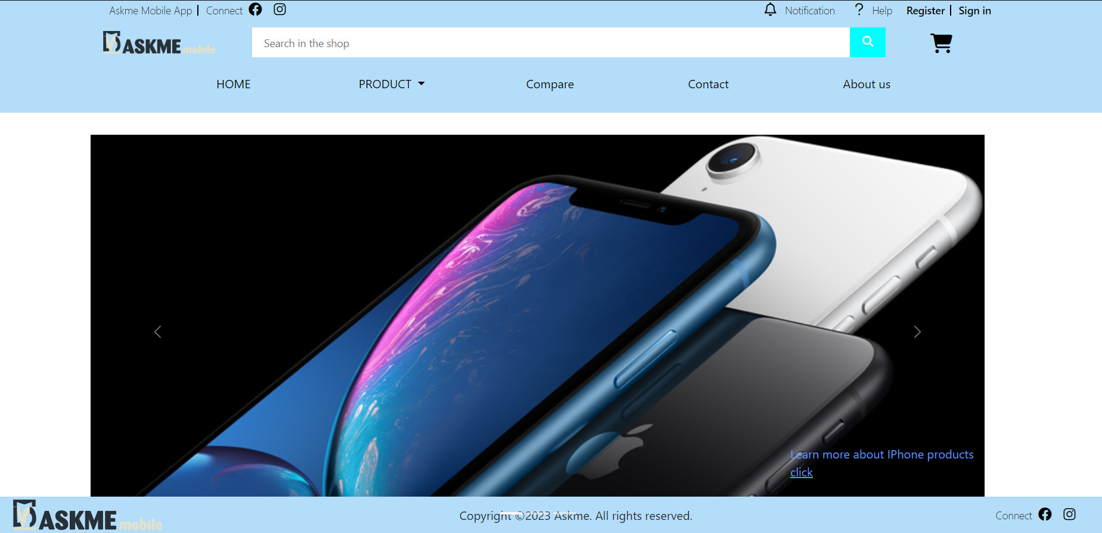

### Product

1. *Description*

This webpage displays mobiles products. Users can sort the products in terms of price, phones and search a particular name by using the search bar. If users want to see the details of a particular product, they will click the red button “View details” and another page will open to show the information of the chosen product.

1. *Screenshot*

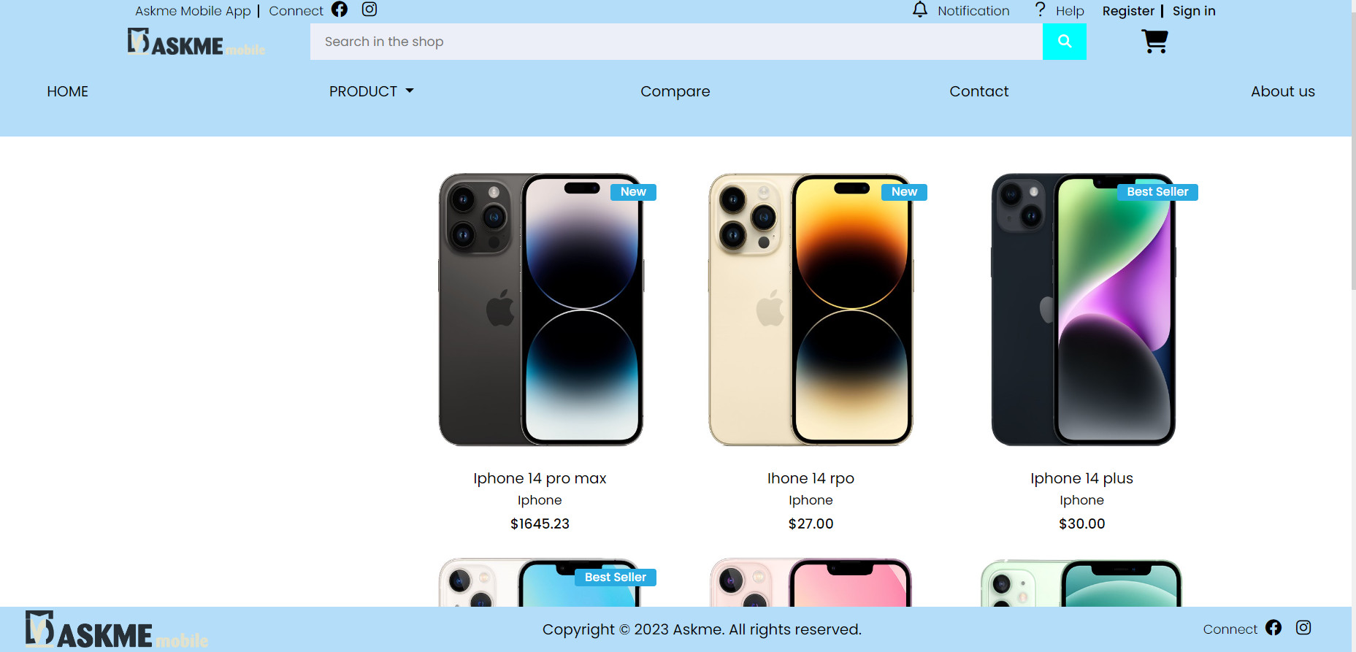

### Example of detailed information page

* *Description*

This webpage displays detailed information of phone, including pictures and specifications.

* *Screenshot*

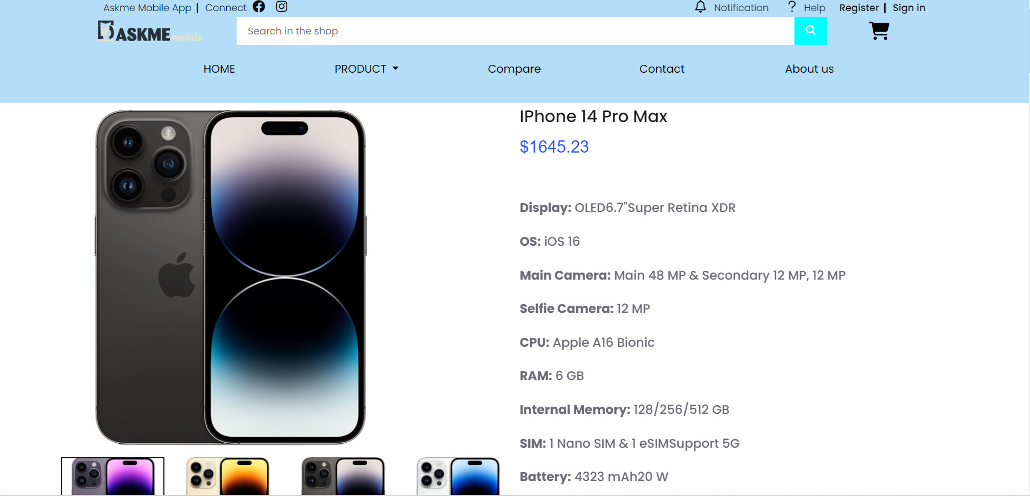

### Compare

1. *Description*

This webpage allows users to make comparison between products provided in the website. Users need to choose which type of product they wish to compare and then click the compare button.

1. *Screenshot*

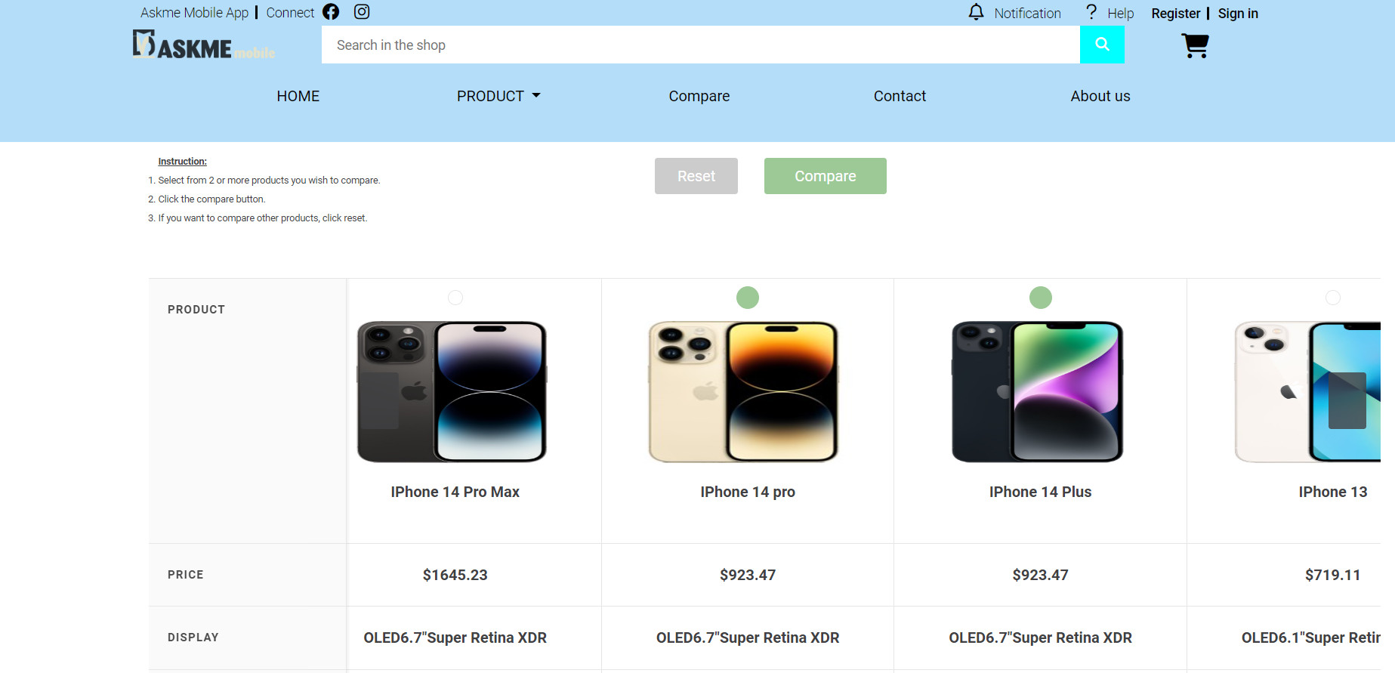

### About us

1. *Description*

This webpage display the information of the company, clients’ review and information about web creators.

1. *Screenshot*

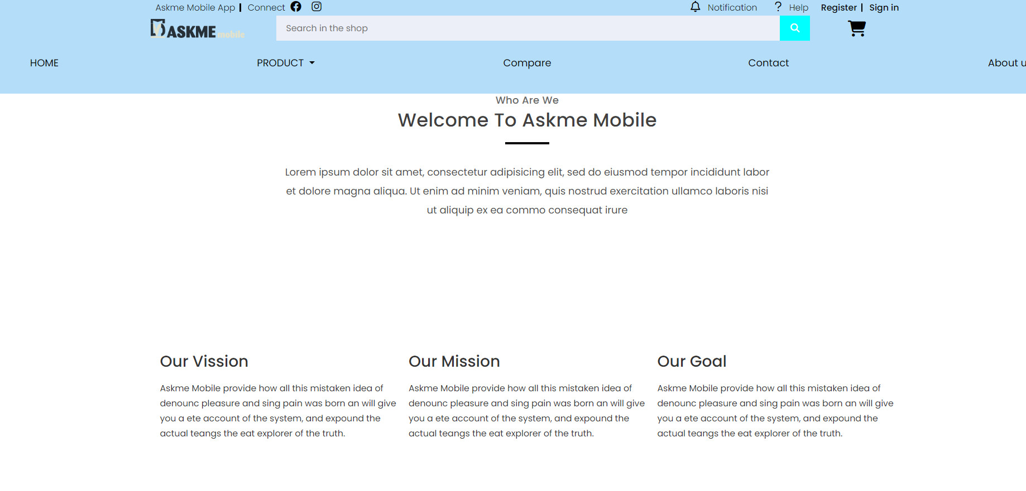

### 6. Contact Us

1. *Description*

This webpage allows users to request information they inquire to AKSME MOBILE and displays the geo location of our company.

1. *Screenshot*

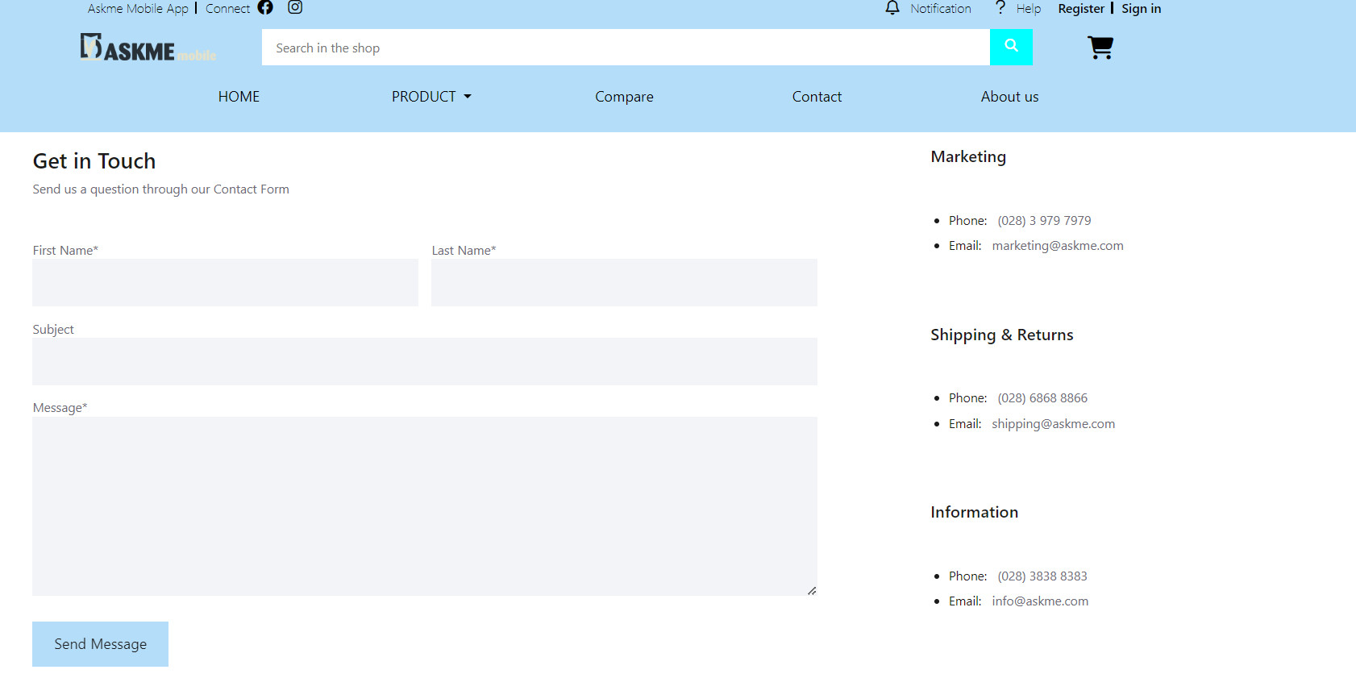

# JAVASCRIPT DESCRIPTION

This chapter will provide information about JavaScript function integrated in the website

### Zoom picture function

1. *Description*

This script is used for zooming pictures of product in detailed information pages. It is implemented with the support the Jquery library and elevateZoom library.

1. *Screenshot*

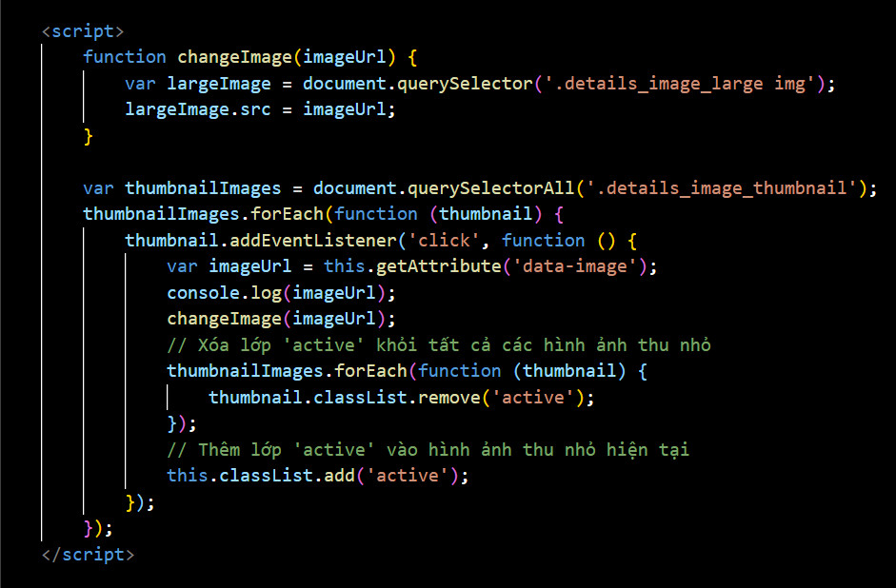

### Compare page function

1. *Description*

This script to compare phone lines with each other.

1. *Screenshot*

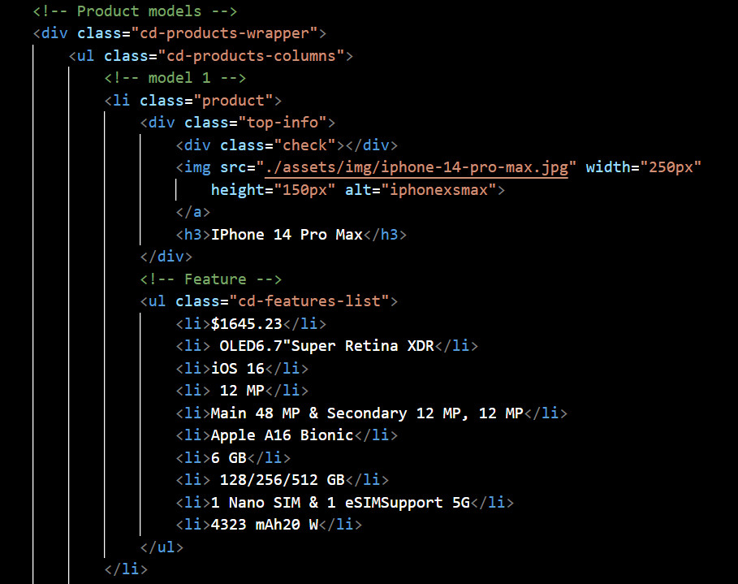

**TASK SHEET REVIEW 3**

|  |  |  |  |  |  |  |  |
| --- | --- | --- | --- | --- | --- | --- | --- |
| ***Project Ref. No.:***  ***eP/Advertisement Portal Management System/01*** | | ***Project Title:*** | ***Activity Plan Prepared By:*** | ***Date of Preparation of Activity Plan:*** | | | |
| ***Sr.***  ***No.*** | ***Task*** | ***Actual Start***  ***Date*** | ***Actual Days*** | ***Team Mate***  ***Names*** | ***Status*** |
| *1* | *Home page* | *AKSME*  *MOBILE* | *Duong* | 10-Jun-23 | *1* | *An* | *Completed* |
| *2* | *Product* | 11-Jun-23 | *2* | *An* | *Completed* |
| *3* | *Compare* | 13-Jun-23 | *3* | *Duong* | *Completed* |
| *4* | *About Us* | 16-Jun-23 | *1* | *Phung* | *Completed* |
| *5* | *Contact* | 17-Jun-23 | *1* | *Duong* | *Completed* |
| *6* | *JavaScript Description* | 18-Jun-23 | *2* | *Duong* | *Completed* |
| *7* | *User Guide* | 20-Jun-23 | *1* | *Phung* | *Completed* |

|  |  |
| --- | --- |
| **Date:** | |
| Signature of Instructor:  **Ms. Le Mong Thuy** | Signature of Team Leader:  **Nguyen Quoc Duong** |